SpiritForms 1.0

Installation Guide
Jan. 2026



Requirements:

The SpiritForms system can be set up in one of two ways (or both if you wish):

1. On a local computer (using localhost)

or

2. In a hosted environment

Localhost setup:

Hardware:

Computer with sufficient memory and storage. Minimum memory: 16GB Minimum storage = 10GB. Minimum Processor: Intel® Core(TM) i7-3612QM CPU @ 2.10GHz Graphics Card: 2 GB

Software:

1. Windows 10 or later.

2. XAMPP or WAMP – Both include Apache web server, MySQL and PHP

3. MySQL 8.0 with MySQL Workbench (strongly recommended)

4. nuBuilder 4.9.2 or later. See nuBuilder initial installation instructions here.
Also see these instructions.

Hosting environment

Any good hosting provider will suffice.

You will need to install:

nuBuilder 4.9.2 or later (also FREE!)

See nuBuilder download and installation instructions here. Also see these instructions.

Note: Before importing an existing database to your hosting server, you may have to do a search/replace regarding collation (for example, search for ‘utf8mb4_0900_ai_ci’ and replace it with ‘utf8mb4_general_ci’) before your database properly imports.

The remainder of the installation instructions assume a localhost environment. You can adapt them for your hosting provider setup as required.

Assuming that you have created your new database and that you have installed nuBuilder and connected to the database, now you can import the SpiritForms application into the database.

The following instructions assume that you have MySQL Workbench available to you. If you don’t have MySQL Workbench, then the process will most likely be somewhat similar with another tool.

1. Log in to MySQL Workbench

2. DROP the tables in the database. Yes, all of them.

3. Go to Server > Data Import

4. Click the ‘Import from Self-Contained File’ radio button

5. To the far right, click the … and navigate to the SpiritForms nuBuilder .sql file you downloaded.
The file name will be:
YYYY-MM--DD_101632_6941a2008fb72_nuBuilder_backup.sql
or something similar.

6. In the Default Target Schema drop-down, select your database/schema name.

7. Click the ‘Start Import’ button in the lower right.

The database tables will be created. Once the import is finished, click the tiny

button at the top of the navigator window.

You should now see all of the SpiritForms and nuBuilder system tables and columns.

8. Close out of MySQL Workbench.

Create an uploads folder on the server

9. At the document root of your server, create a folder called uploads.

Example: C:\xampp\htdocs\uploads

This is required for SpiritForms file uploads.

10. Under the Uploads folder, create two more folders: /Evidence and /History. These two folders will hold multimedia files for the Report Templates. These folders are for maintaining the Report templates only.

REQUIRED: Web Root Alias for /uploads

SpiritForms (built on nuBuilder Forte 4.9.2) requires the /uploads directory to be accessible from the web root.

This is not optional.

nuBuilder automatically normalizes <img src> paths to relative URLs when saving HTML content (e.g., Report Templates, Notes, WYSIWYG content).
If /uploads is not globally reachable, image links will break after saving.

Why this is required:

nuBuilder rewrites image paths on save like this:

/uploads/... → ../uploads/...

This behavior applies only to <img> elements

Audio, video, and anchor links are not rewritten

nuBuilder assumes /uploads exists at the web root

Therefore, /uploads must resolve correctly regardless of form depth or URL context.

Apache (Recommended)

Add the following to your Apache configuration
(e.g., httpd.conf or httpd-vhosts.conf):

Alias /uploads "C:/your-web-root/SpiritForms/uploads"

<Directory "C:/your-web-root/SpiritForms/uploads">
AllowOverride All
Require all granted
</Directory>

Restart Apache after saving changes.

Linux / Production Example
Alias /uploads "/var/www/SpiritForms/uploads"

<Directory "/var/www/SpiritForms/uploads">
AllowOverride All
Require all granted
</Directory>

Verification Step (Required)

After installation, confirm that the following URL loads a file correctly:

http://yourdomain.com/uploads/

If this URL does not resolve, image rendering inside SpiritForms WYSIWYG editors will fail after saving.

Important Notes

Do not remove or disable this alias

Do not attempt to “fix” image paths in PHP or JavaScript

Do not rely on relative paths inside HTML content

This alias ensures:

Image stability in Report Templates

Correct rendering in Notes

Proper display in printed reports

Forward compatibility with nuBuilder updates

NOTE: Shared Hosting Limitation
On shared hosting platforms where Apache virtual host access is restricted, the required /uploads alias cannot be created. In these environments, image paths rewritten by nuBuilder may not resolve correctly after saving WYSIWYG content. This is a known limitation of the hosting environment, not of SpiritForms itself.

Enable .zip files in php.ini

SpiritForms needs access to .zip file upload/download functionality in Tiny File Manager.
To enable that, we need to enable ZipArchive in php.ini.
In your file system, find your php.ini file and uncomment the following line:

‘extension=zip'

Without doing this, SpiritForms uploads/download of .zip files will not work.

Add two lines of code to nuconfig.php

You should have already modified nuconfig.php to connect SpiritForms to your database.
The file is located here:

C:\xampp\htdocs\your_nuBuilder_folder\nuconfig.php

Now we need to modify it to add two important lines of code.

Inside that file, find:

// Settings
$nuConfigSettingsFromDB = true; //-- Use settings from setup->settings if set to true (default)

Immediately below that ADD these two lines:

$nuUploadsRoot = rtrim($_SERVER['DOCUMENT_ROOT'], '/\\') . '/uploads'; //-- Defines document upload root folder
$nuUploadsUrl = '/uploads';

The entire block of code should now be:

// Settings
$nuConfigSettingsFromDB = true; //-- Use settings from setup->settings if set to true (default)
$nuUploadsRoot = rtrim($_SERVER['DOCUMENT_ROOT'], '/\\') . '/uploads'; //-- Defines document upload root folder
$nuUploadsUrl = '/uploads';

Save the file.

Custom SpiritForms Files Placement - ***IMPORTANT***

Two custom .php files were included in the zip file that you downloaded. They should be in a separate folder named Custom SpiritForms Files within the .zip file.

1. get_note.php – required for selecting Report templates in SpiritForms
To install this file, create a new folder called /custom on the server with a path as follows:

C:\xampp\htdocs\your_nuBuilder_folder\your_nuBuilder_folder\custom

and place the file there.

2. get_user_email.php – required for selecting email recipients in SpiritForms
Place this file in the same directory as in step 1 above.

Customized nuBuilder Files Placement - ***IMPORTANT***

There are three nuBuilder system files that have been customized. These files must replace existing nuBuilder files. It is strongly recommended that you make backup copies of the original files before replacing them.

You will find the customized files in a folder called:
Customized nuBuilder Files
They will be in a sub folder called ‘core’ in the zip file. This is a reminder that these are nuBuilder core files. They are:

nuace.php
nuform.js
nurunhtml.php

Place them in this location:

C:\xampp\htdocs\your_nuBuilder_folder\core

Tiny File Manager custom file

1. Tiny File Manager ‘config.php’
Put this file in this folder:

C:\xampp\htdocs\your_nuBuilder_folder\third_party\tinyfilemanager\config.php

SpiritForms ‘Capture Page Chrome Extension

You will find a separate .zip file called ‘CapturePageChromeExtension.zip’ in the download.
This custom Chrome extension is required for you and your clients to be able to capture and download SpiritForms Reports. Separate installation instructions are included within the .zip file. Please read and follow those instructions. Note: This Chrome extension is not required to view reports.

Email Setup

1. Log in to SpiritFormss as globeadmin
2. Click ‘Setup’

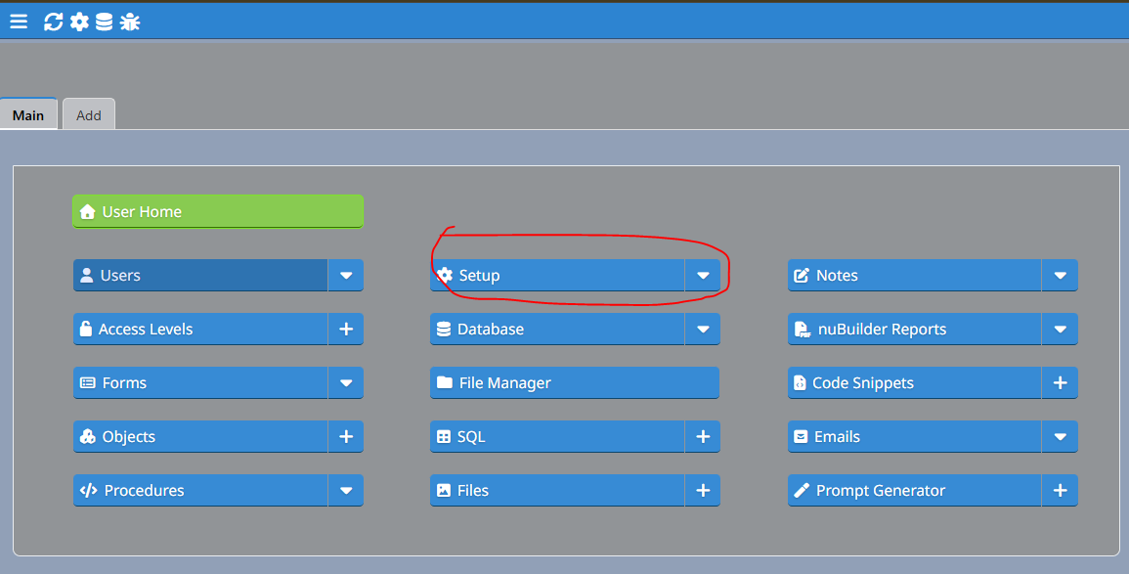

3. Click the ‘Email’ tab.

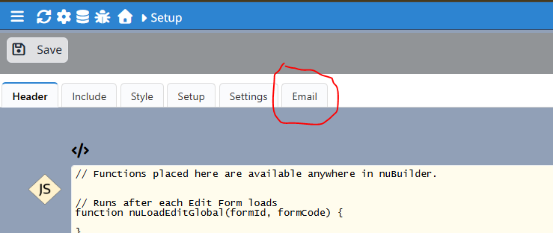

Login Page Customization

The server administrator can easily customize the application Login page by editing the nuconfig.php file.

1. Open nuconfig.php in notepad or notepad++.

2. Go to line 110. There you will see a comment as follows:

// Alternatively, uncomment this block to customize the whole login form (note: $nuConfigLogonMode will be ignored):

Make your custom edits in the code below this line to customize the login page.

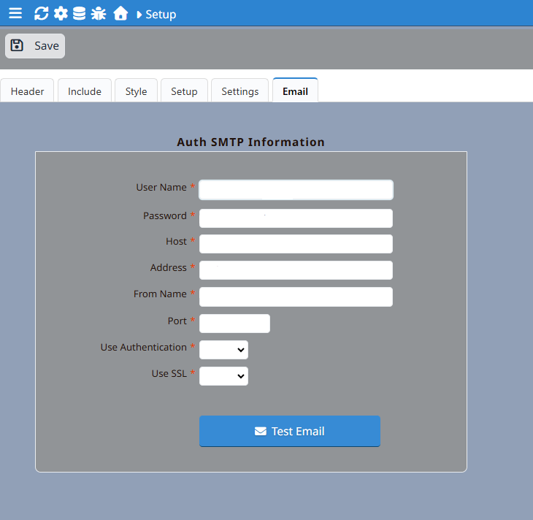

4. Enter the required information.
5. Click the ‘Test Email’ button to verify that the email setup is successful.

This email account will be the ‘Inbox’ for all Client email replies. The emails in this account will be used to populate the Emails From The Client field for each investigation record.

